MCAS – data display

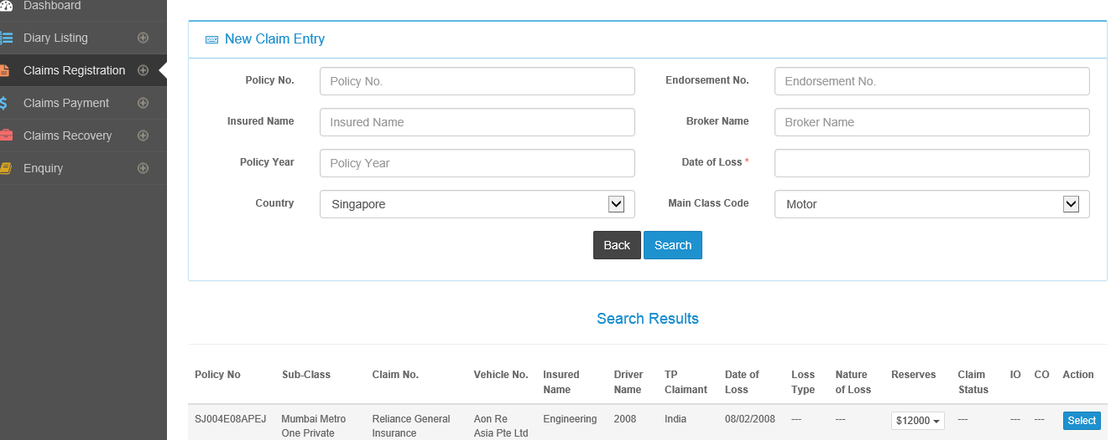

Data display –

1. Sub-Class column – data from Admin – SubClass – for example -> Motor Comprehensive
2. Claim No – you can display current claim numbers in Beazley version
3. Vehicle No. – use the example that I have updated in SRS
4. Insured Name – could be Comfort Transportation (owns taxis), CityCab (also owns taxis) or SBS Transit (owns buses and rail)
5. Driver Name – name of person – for example John Chang, Ahmad Shukor and Bala Ramesh
6. TP Claimant – this will generally be name of persons – you can coin samples on your own
7. Claim Status – could be Outstanding, Closed
8. IO = Investigating Officer – this will be name of person
9. CO=Claims Office – this will be name of person